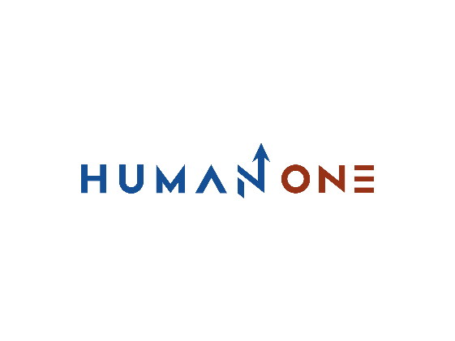

Services

Big Data & analytics

Platform Development

Expertise

**EN**

**FR**

Get in touch

Company

Cloud

Devops

Machine learning & IA

UI/UX Design

# **Maching learning & IA**

**Engage your customers with the exceptional UI/UX design**

You never have a second chance to make a first impression. At HumanOne, we apply a full range of UI/UX services to build efficient customer retention strategies and help brands create genuine, human-centered identities that engage, excite, and build trust. We push brands to define their image with UI design services and make an enduring impact that drives and inspires users with UX design services. Yet, providing an extensive set of UI/UX services, HumanOne can cut delivery times by a third — or even in half. Showcase your brand and exceed user expectations with our UI/UX design services



Let’s Talk

**Mobile app design**

Ensure immersive customer experience and increase the efficiency of your multi-channel presence through intuitive and streamlined mobile designs powered by our UI/UX services

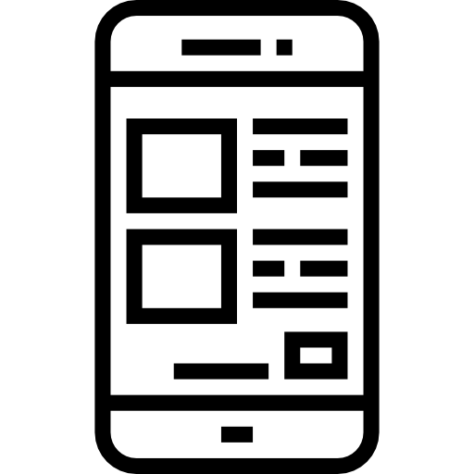

**Our UI/UX services**

With HumanOne UI/UX services, we help businesses build strong emotional bonds with their customers through appealing visual designs and memorable brand experiences. Emotions and ultra-personalization are shaping the behavior of today's consumers, which is why we apply human-centered user experience services to build brand loyalty over time. An accessible and impressive design is a powerful tool for growing faster than the competition, improving customer acquisition, and boosting your conversions.



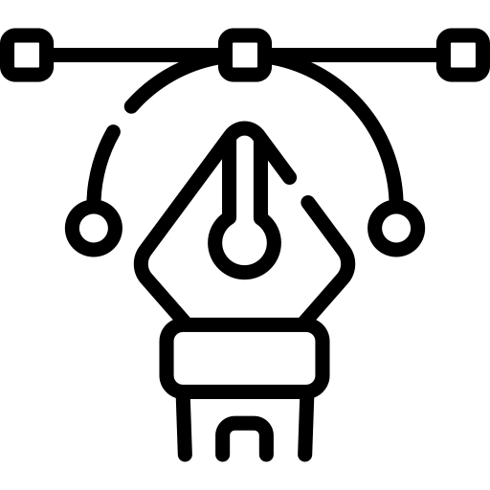

**HMI design**

Increase productivity, maximize operational efficiency, and automate processes by applying our UI/UX design services to create highly responsive and user-friendly human interfaces

**Graphic design**

Propel business growth with HumanOne UI design services for a well-thought-out visual identity that will help you stand out from competitors and make a lasting impression on customers

**Web design**

Run your business more effectively with platform-specific adaptive and responsive web designs, adapted to each device type, needs, and environment with UX design services

**Our approach**

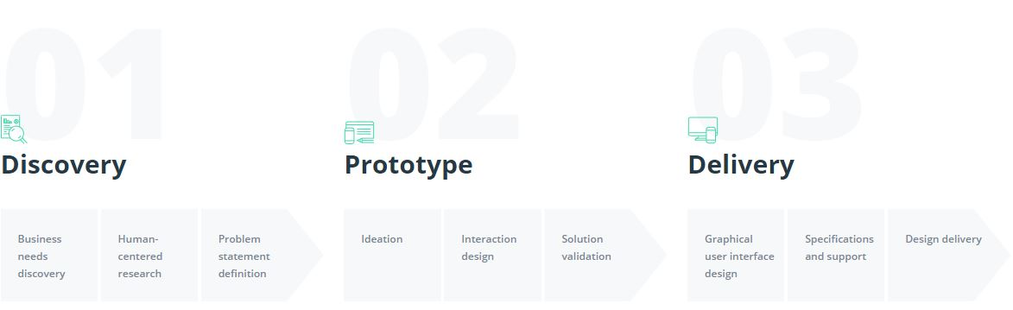

**04**

Keep to rollout timeframes and minimize the chance of a budget overrun with the help of a time- and budget-friendly strategy backed by our UX services

Increase future product adoption by applying UI/UX services to design products and services that are suited to users’ needs and preferences

**06**

**05**

**03**

**02**

**01**

**Benefits of UI/UX design you will get**

Reach your target audience with an efficient customer satisfaction, loyalty, and retention strategy based on our customer-focused UX design research

Meet customer needs with all-encompassing and human-centered UI design services, user experience services, and design research

Avoid the risk of coding faulty user flows and excessive features by validating ideas and potential solutions with little investment of time and money in UX services.

Boost customer acquisition and retention rates by developing fit-for-purpose designs with our UI/UX design services

Get in touch

## **Increase customer engagement with UI and UX design servicescompanies offer?**

### **Lean development**

User experience and user interface design services help organizations validate business ideas, saving money on development. Digital prototyping and alternative mock-ups let business owners test features before implementation. This lets companies avoid unnecessary expenses while still getting an accurate and realistic evaluation of the elements of their app or website.

By testing how users interact with an application or website, organizations can get a clear understanding of which functions are useless or need improvement. User experience design services bring flexibility to the development process and save money down the line. With correctly implemented prototypes and validated features, companies can avoid change requests and make sure no requirement is missed.

### **Increase revenue**

Many businesses lose customers and money because their applications or websites provide a poor user experience. Usability, simplicity, consistency, and responsiveness can make people fall in love with an app or website, becoming loyal customers from day one. By turning to user interface design services, enterprises invest in higher conversion rates and increased revenue.

Moving forward, AI adopters can integrate already designed and trained neural networks into their machine learning solutions to increase efficiency at a lower cost. Another scenario is to introduce computer vision technology to recognize critical objects from video or another multimedia data source. When finalizing your AI implementation, you should approach a mix of machine learning solutions and models and integrate tools to visualize business outcomes

**Differentiate your brand**

The market is flooded with look-alike products, but a product has to stand out to win an audience. Customers choose a product based on the user experience it offers. Is it intuitive? Does it offer exactly what they came for? A quality user experience and an attractive user interface design for web applications and mobile solutions is critical to establishing a brand’s name on the market.

Good design is catchy. It lures, converts, and engages. It responds to customer needs and alters the way customers feel about products or services. Businesses can astonish, tell stories, build connections, and embrace so many opportunities with quality user experience design services. A brand is an experience. If it isn’t unique, who will be able to differentiate it from its competitors?

